Stationery Online Station

Enterprise Systems Development (ITP4511)

Assignment Report

Hong Kong Institute of Vocational Education (TY)

Higher Diploma in Software Engineering (IT114105)

Group number:

Member List

|  |  |  |
| --- | --- | --- |
| Class | Student Name | Student ID |
| IT114105/2A | Tse Wai Tsun | 140174220 |
| IT114105/2A | Wong Pui Ho | 140377489 |
| IT114105/2A | Cheung Ming Wai | 140501493 |

CONTENT

1. Assumption and the user and system requirements 2

2. Site map 4

3. System structure 6

4. Database structure 7

5. Tools, installation set, testing procedures and dataset 10

6. Test plan and Test cases 11

7. Brief description 33

8. Conclusions 34

9. Skill checklist 35

1. Assumption and the user and system requirements

This report is based on several assumptions drawn:

The company, Stationery Station is a stationery supplier, providing the office consumable stationeries for bulk purchase. It is going to design an online shop with easy-to-use online system, named as Stationery Online Station (SOS) to let the clients to order their products online. Also the system has an administration system for manage to manage the product and handle daily operations.

There are two user can use the system- client and manager.

The client do registration by input their information (name, telephone number, and delivery address). After registration, the manager will provide the client id and password to the client by phone message.

After log in by id and password, client can place and manage order, check the last 10 orders history, maintain the personal information, check the bonus point and redeem gift.

Manager can maintain details of the item, update the order status, verify the client identity and provide client id and password, approve credit amount for client and obtain a report for incomplete orders.

Requirement of Client:

|  |  |
| --- | --- |
| Function | Description |
| Registration | Client uses the id and the password to logs in to the system.  Register info: (name, telephone number, delivery address)  The client id and password is sent by phone message. |
| Place and manage order | Client will choose for delivery or self-pick up by place order. If self-pickup is selected, the client has to enter the pick-up date. Client can cancel the order. |
| Check the last 10 orders history. | Client can check the last 10 orders history. |
| Account management | Client can maintain the personal information and delivery address. |
| Check the bonus point | Client can check the bonus point. If the client makes an online order with an amount over HKD1000 dollars in one single order, 100 bonus points will be awarded for every 1000 dollars order. |
| Redeem gift | Client can use bonus point to exchange gifts. |

Requirement of Manager:

|  |  |
| --- | --- |
| Function | Description |
| Maintain product | Manager can add or update the details of the product details. |
| Update order | Manager can update the order status to process, cancel, delivered, or picked-up. |
| Verify the client identity | Manager verifies the client identity and provides a client id and password to the client. |
| Approve credit amount for client. | Manager can approve credit amount for client. |
| Obtain incomplete orders report | Manager can obtain incomplete orders report. |

1. Site map

For Client:

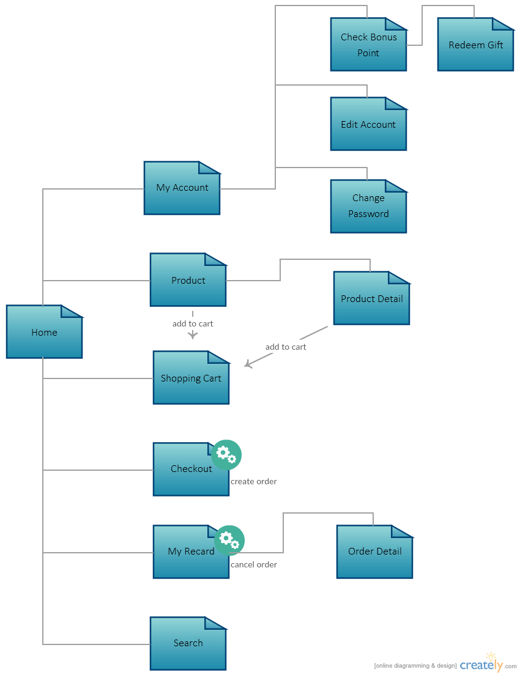

For Manager:

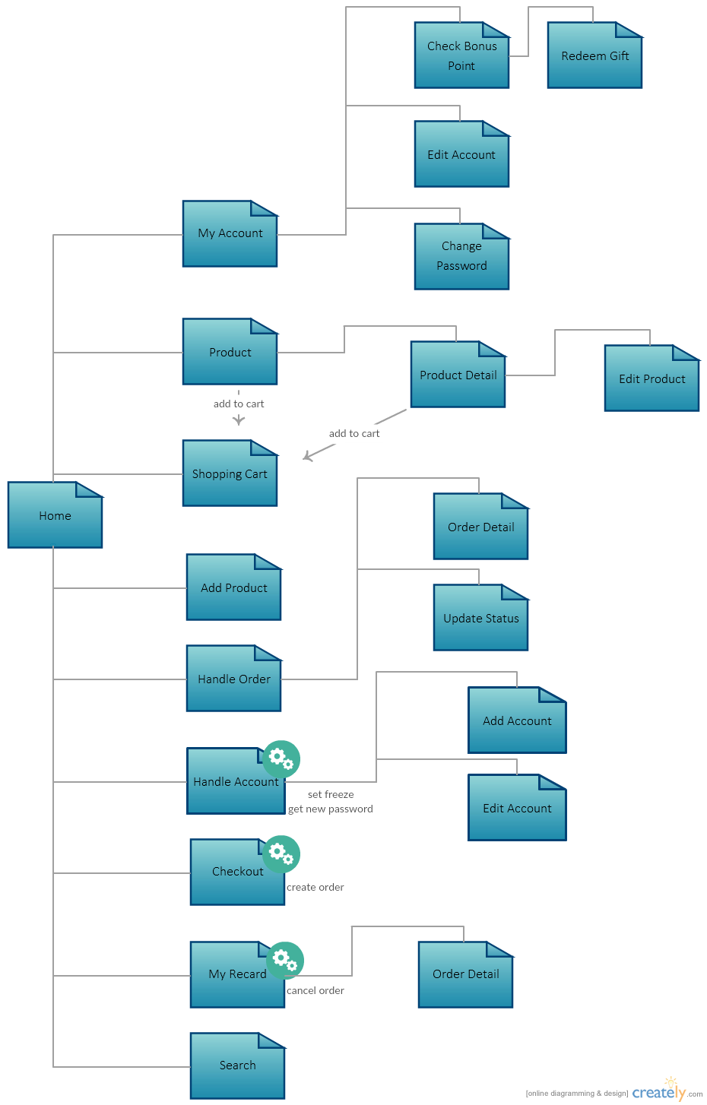

1. System structure

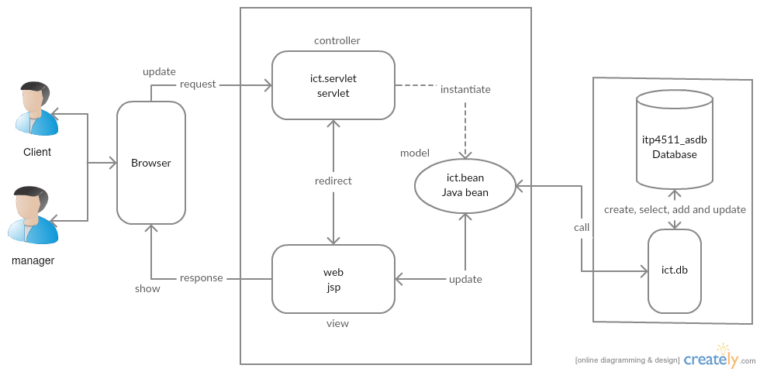

For the system, the MVC Model is applied:

1. Controller - extends HttpServlet, acts as the point of entry into the application, and delegates to various worker classes to fulfill a request. In particular, the Controller is a user of Model and View objects.
2. Model - data-centric classes encapsulating problem domain objects. Each class corresponds roughly to the rows of a database table. Model objects can be constructed from a ResultSet of a database query, or from HTTP request parameters.
3. View - implemented as Java Server Pages (or a similar tool), primarily concerned with presentation and formatting of Model objects which have been placed in scope by the Controller (or its delegate).
4. Database structure

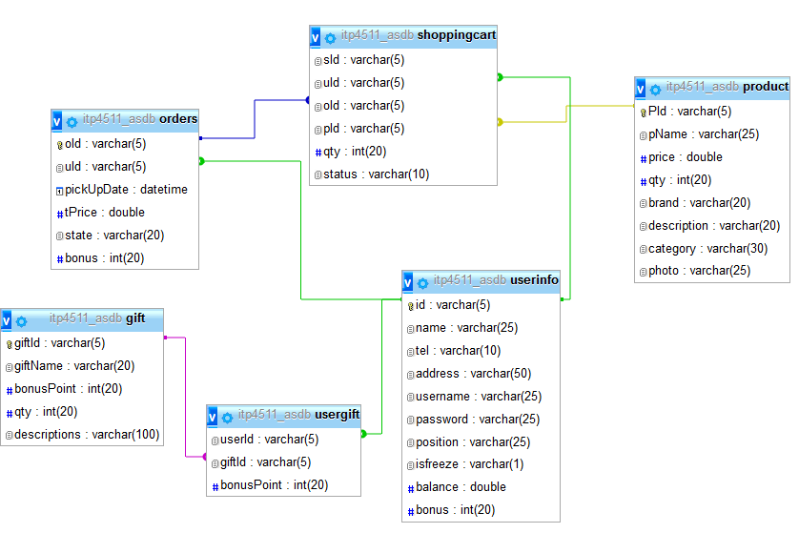

User Info:

|  |  |  |  |
| --- | --- | --- | --- |
| Column | Type | Null | Description |
| id | varchar(5) | No | PK |
| name | varchar(25) | No |  |
| tel | varchar(10) | No |  |
| address | varchar(50) | No |  |
| username | varchar(25) | No |  |
| password | varchar(25) | No |  |
| position | varchar(25) | No |  |
| isfreeze | varchar(1) | No |  |
| balance | double | No |  |
| bonus | int(20) | No |  |

Product:

|  |  |  |  |
| --- | --- | --- | --- |
| Column | Type | Null | Description |
| PId | varchar(5) | No | PK |
| pName | varchar(25) | No |  |
| price | double | No |  |
| qty | int(20) | No |  |
| brand | varchar(20) | No |  |
| description | varchar(20) | No |  |
| category | varchar(30) | No |  |
| photo | varchar(25) | Yes | Default-null |

Gift:

|  |  |  |  |
| --- | --- | --- | --- |
| Column | Type | Null | Description |
| giftId | varchar(5) | No | PK |
| giftName | varchar(20) | No |  |
| bonusPoint | int(20) | No |  |
| qty | int(20) | No |  |
| descriptions | varchar(100 | No |  |

UserGift:

|  |  |  |  |
| --- | --- | --- | --- |
| Column | Type | Null | Description |
| userId | varchar(5) | No | FK-> userinfo.id |
| giftId | varchar(5) | No | FK-> gift.giftId |
| bonusPoint | int(20) | No |  |

ShoppingCart:

|  |  |  |  |
| --- | --- | --- | --- |
| Column | Type | Null | Description |
| sId | varchar(5) | No | PK |
| uId | varchar(5) | No | FK-> userinfo.id |
| oId | varchar(5) | Yes | FK -> orders.oId  Default-NULL |
| pId | varchar(5) | No | FK -> product.PId |
| qty | int(20) | No |  |
| status | varchar(10) | No |  |

Orders:

|  |  |  |  |
| --- | --- | --- | --- |
| Column | Type | Null | Description |
| oId | varchar(5) | No | PK |
| uId | varchar(5) | No | FK-> userinfo.id |
| pickUpDate | datetime | Yes | Default-NULL |
| tPrice | double | No |  |
| state | varchar(20) | No |  |
| bonus | int(20) | No |  |

1. Tools, installation set, testing procedures and dataset
2. Test plan and Test cases
3. Do registration

Name: Maggie, Tel no: 98765432 and Delivery Address: IVE (TY)

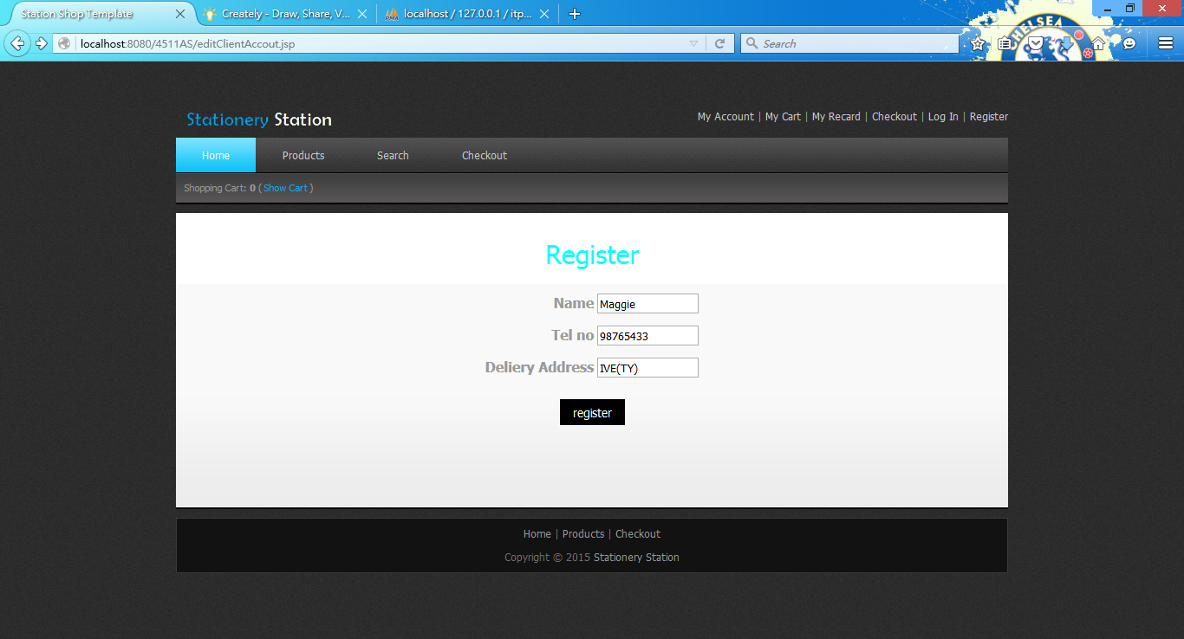

1. Log in with Manager Account.
2. Click in to Handle Account, the new client is shown.

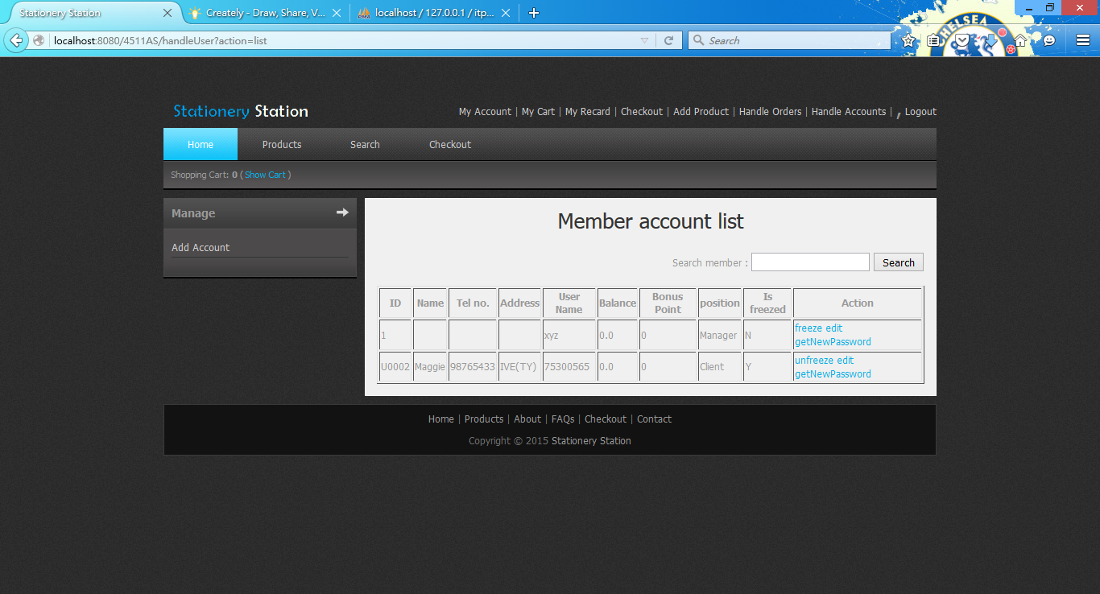

1. Click Handle Accounts and click Add Account to create a new manager account. 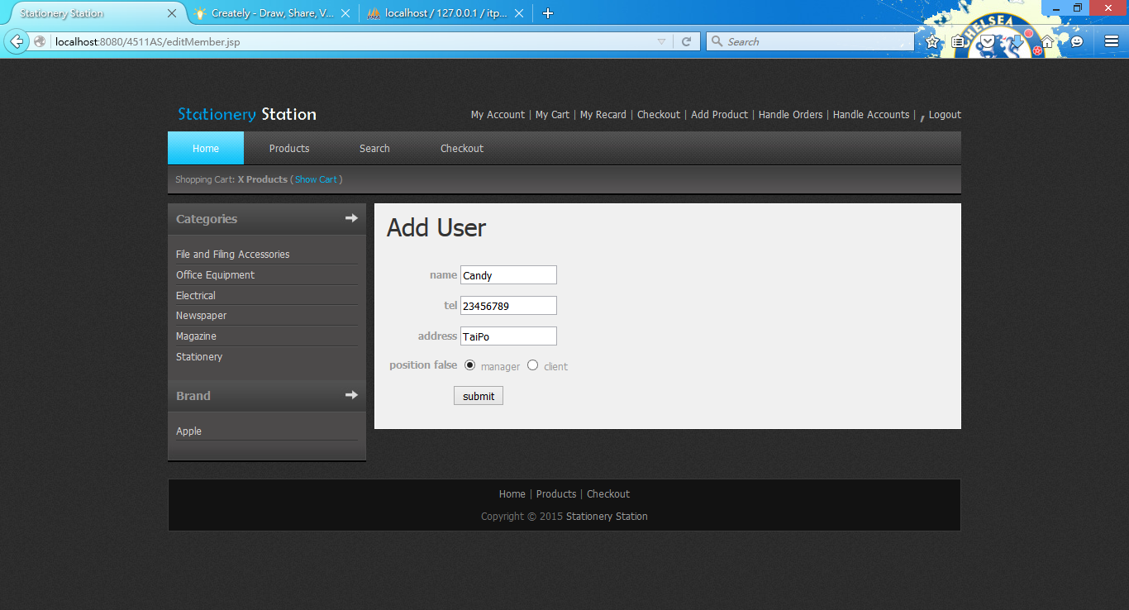
2. Click submit. 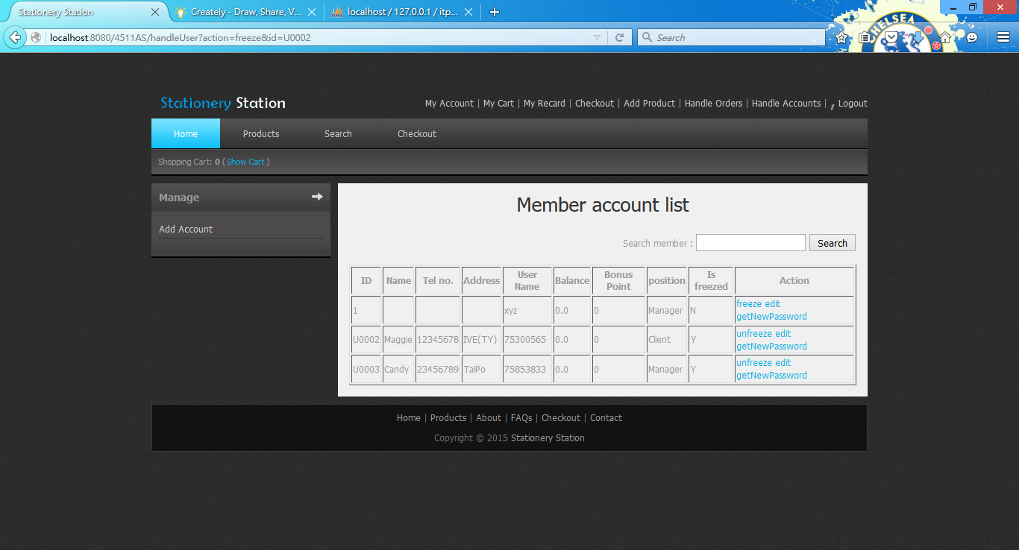
3. Click edit with new manager account to change address to TP. 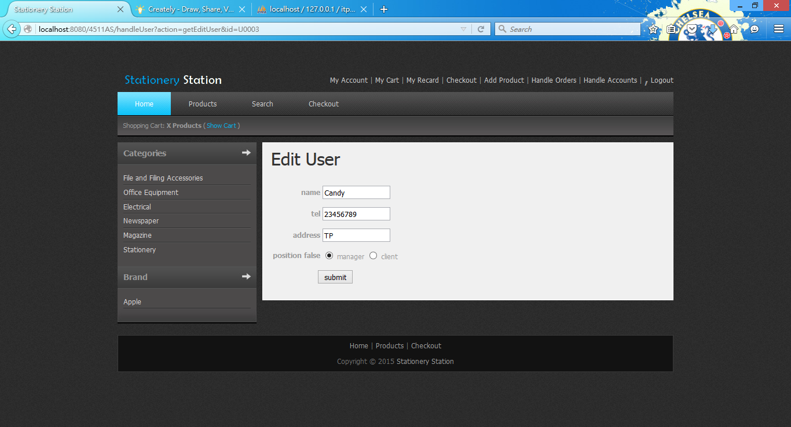
4. Click submit. 
5. Click the account with unfreeze and log in with this account

username: 75300565, password: U@UatP@=.

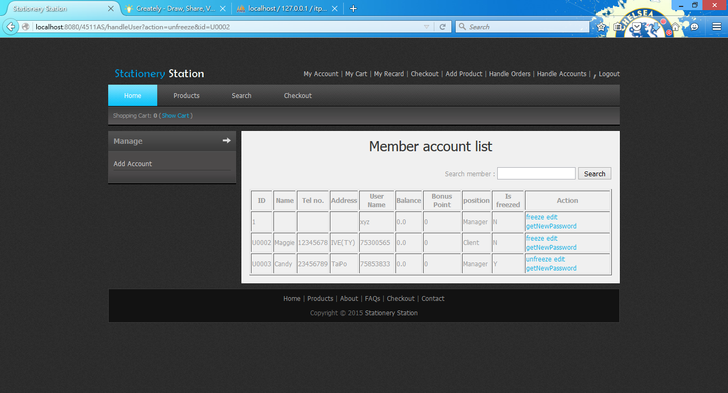

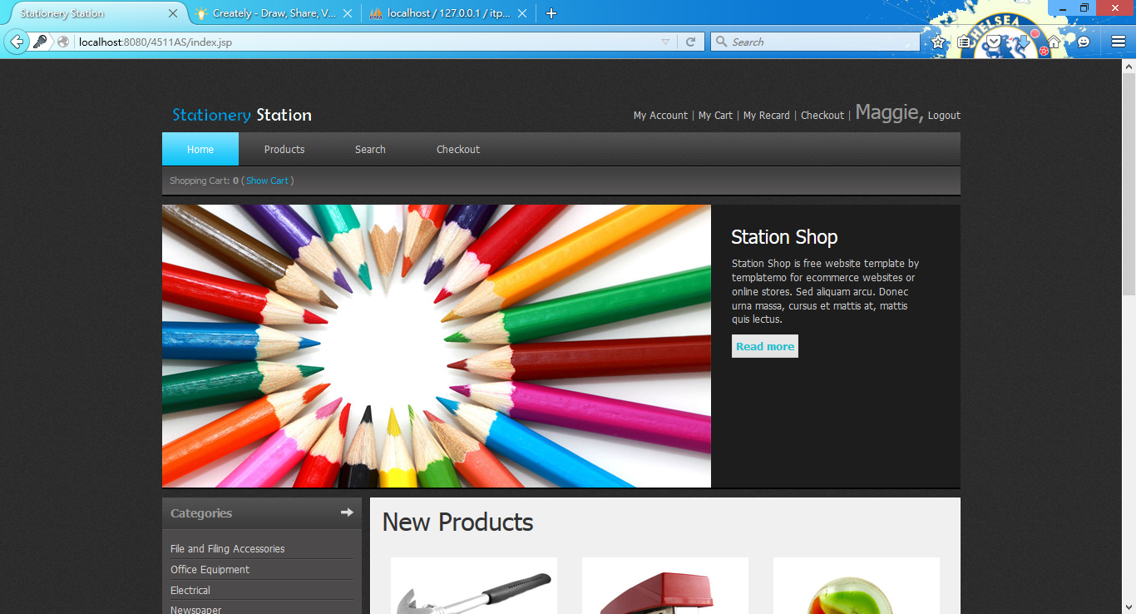

1. Click My Account and show the account detail.

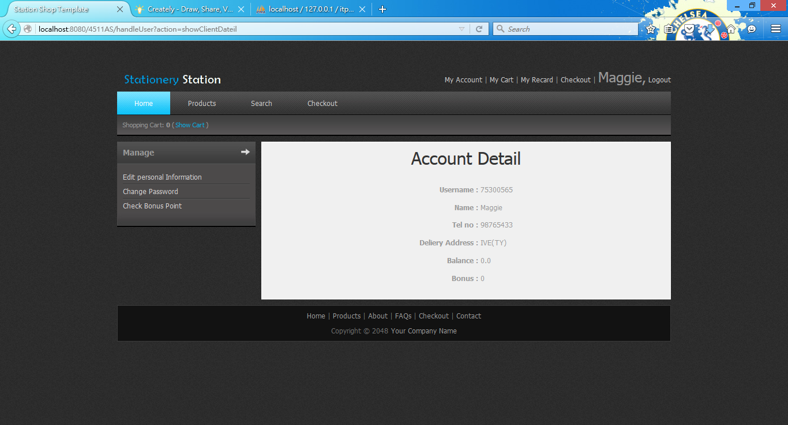

1. Click edit account information and enter the Tel no to 12345678.

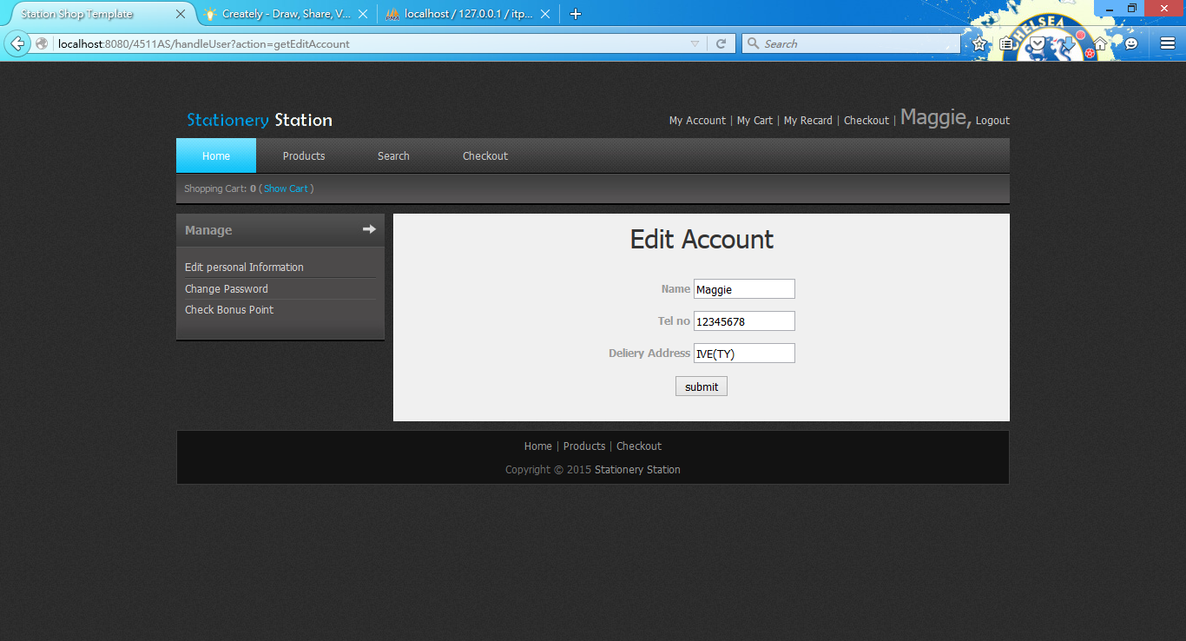

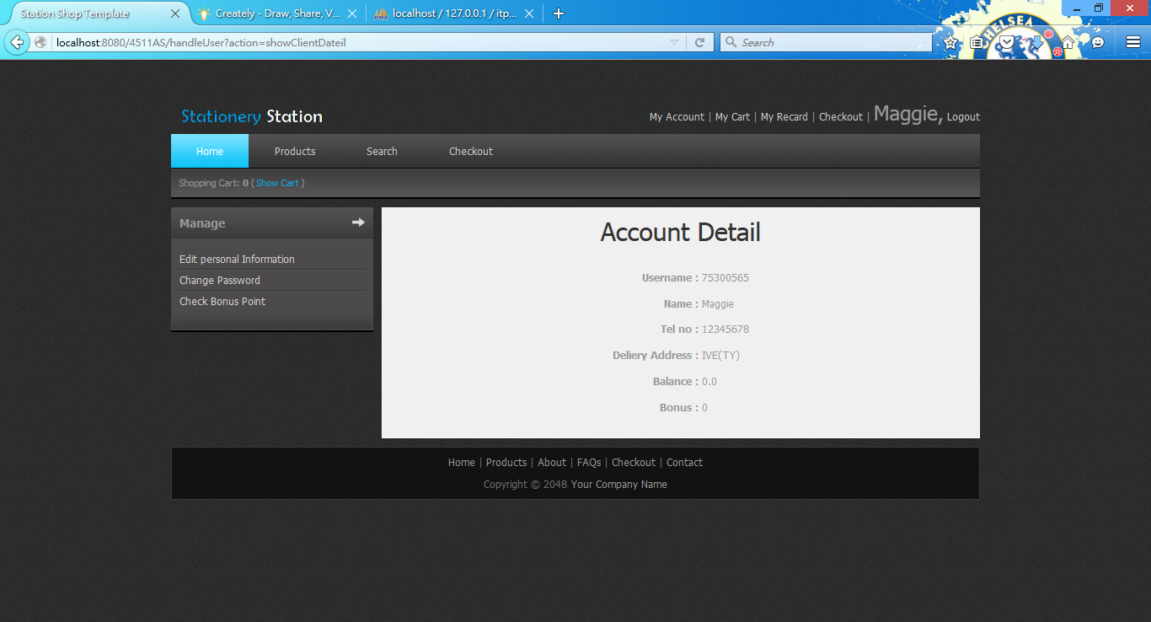

1. Click change password and enter new password to 123.

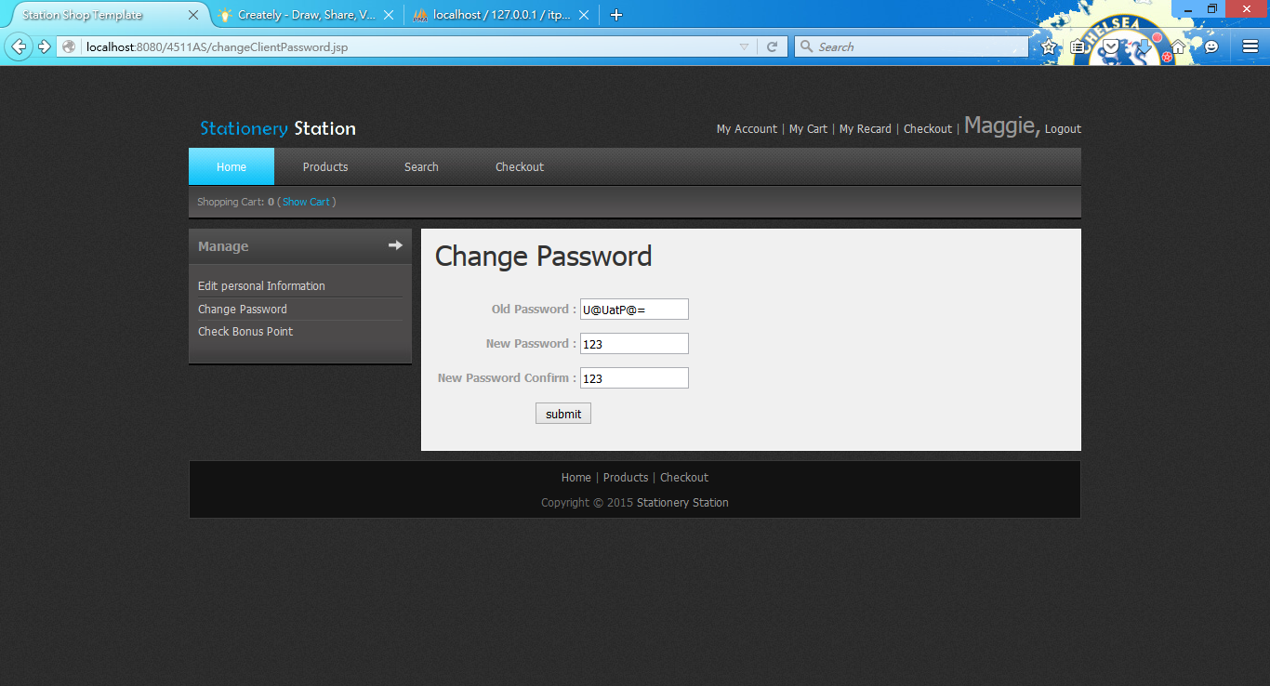

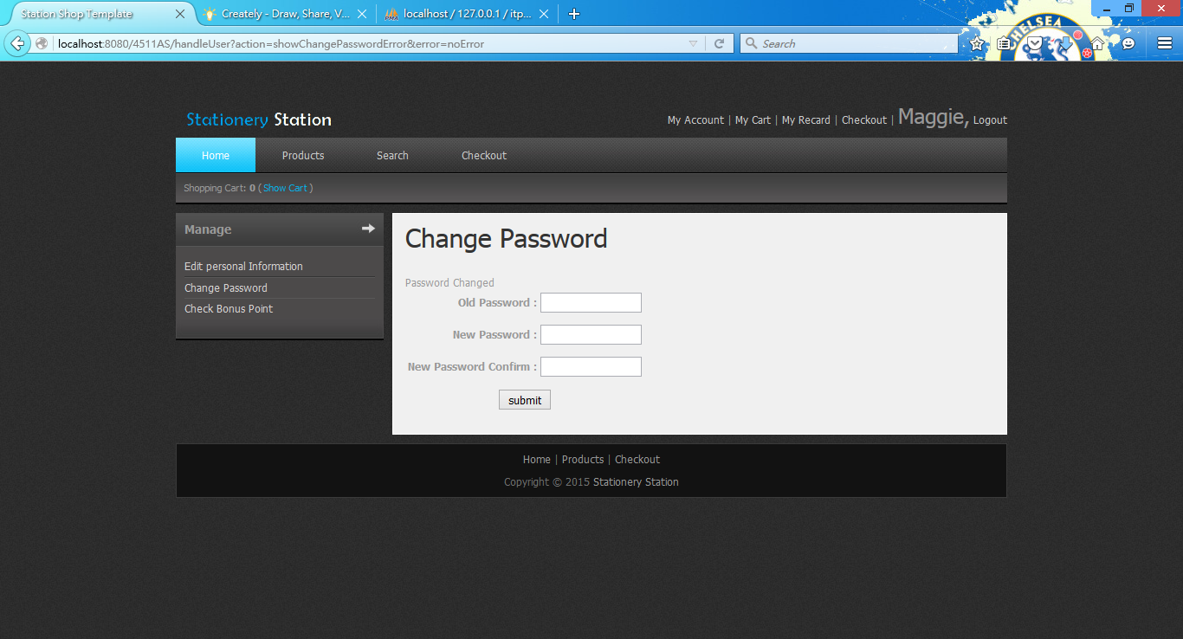

1. Click product and enter Add to cart to add a product” Integer eleifend sed” into the shopping cart.

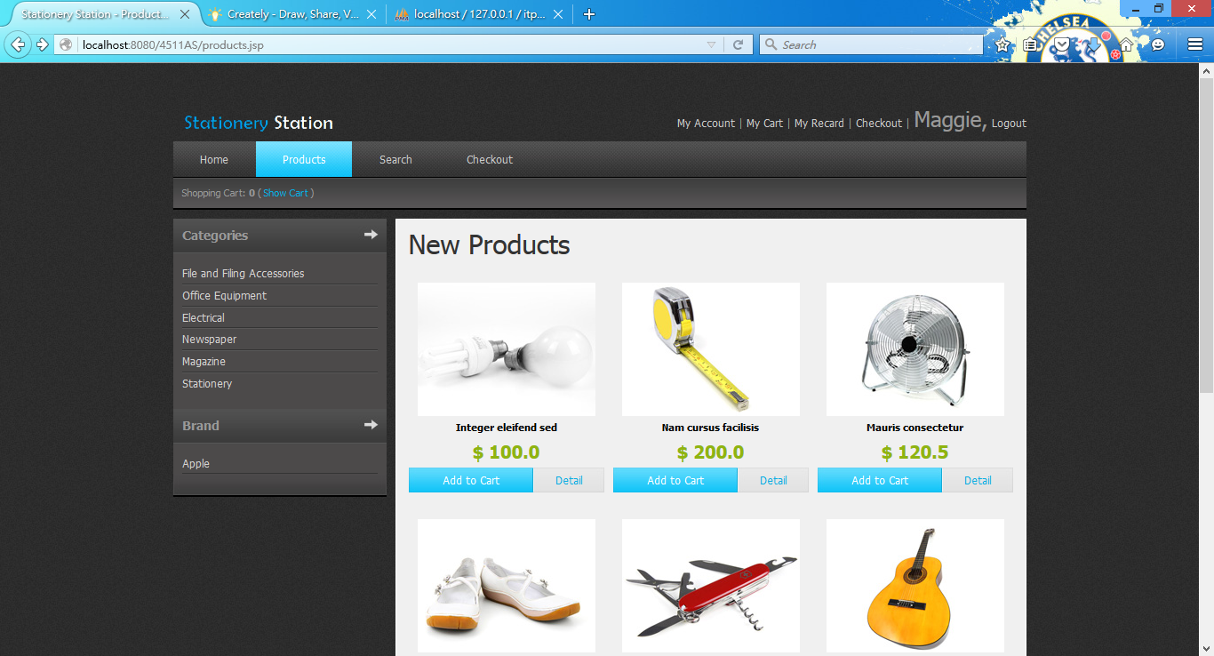

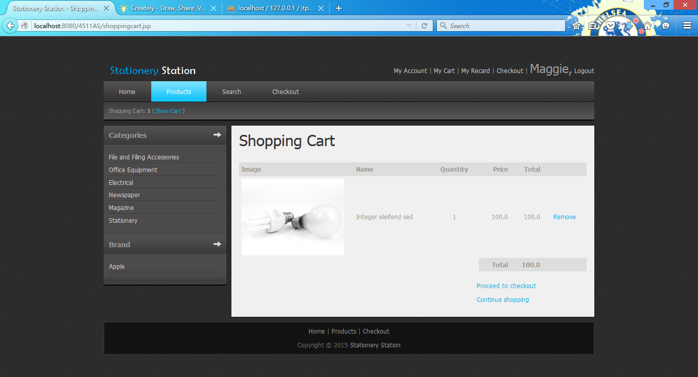

1. Add the same product again.

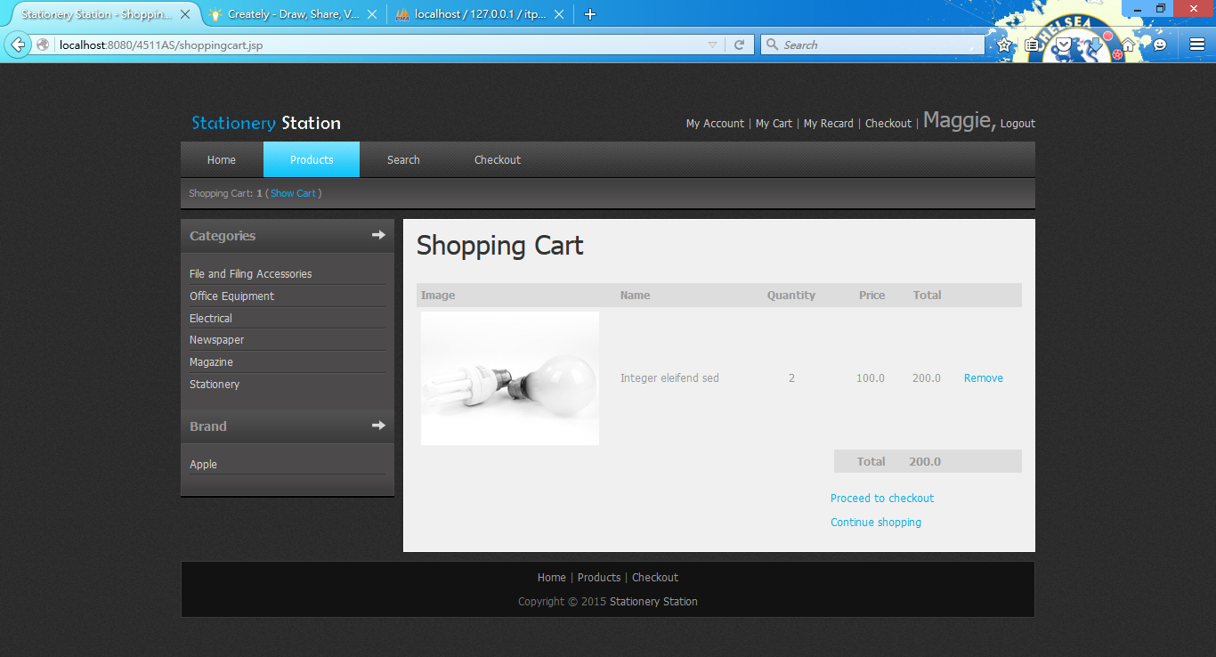

1. Click product and enter Detail.

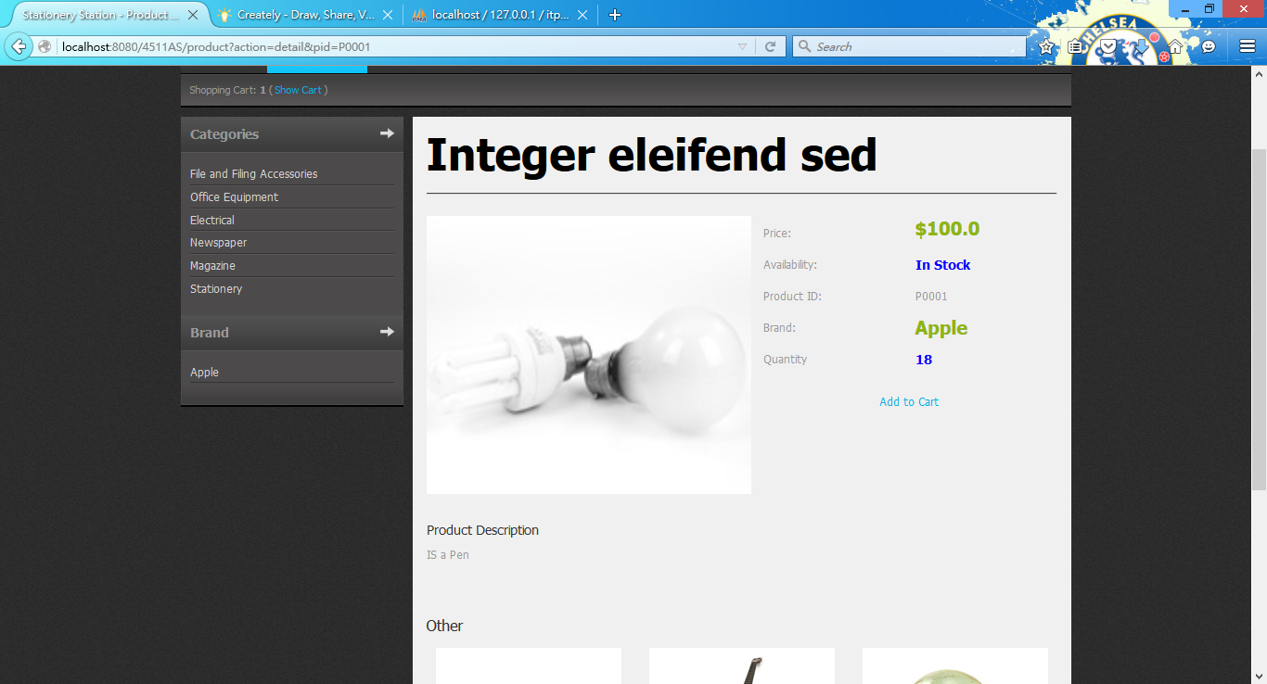

1. Add to Cart and go to detail again.

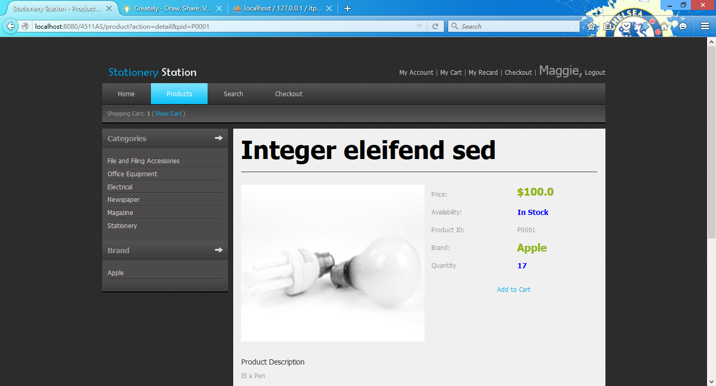

1. Click search and search with Category “Office Equipment”.

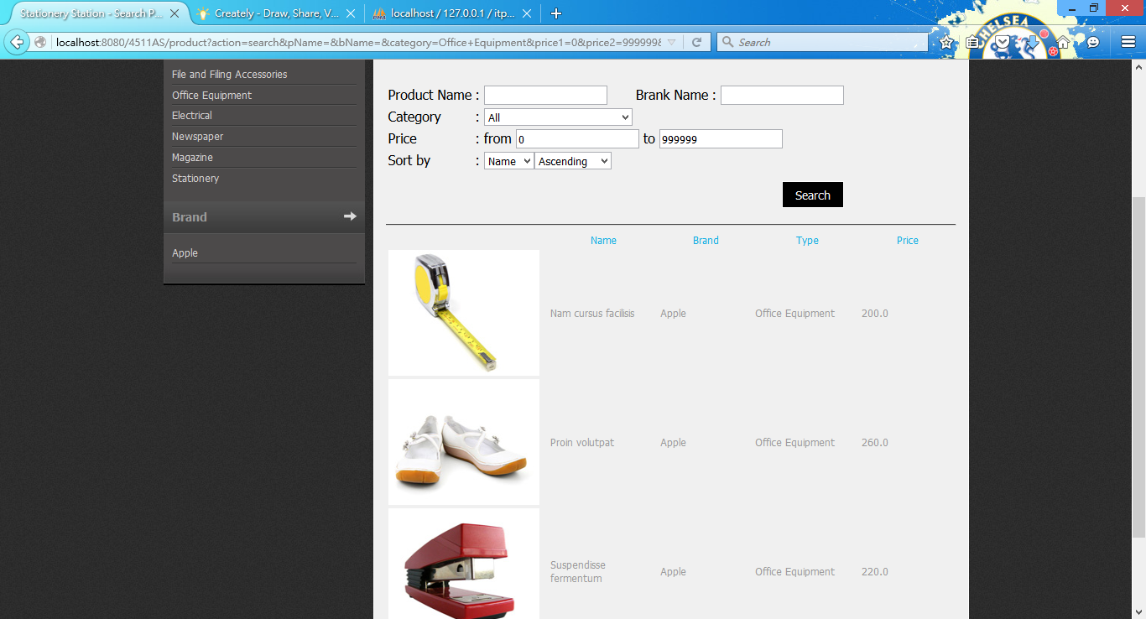

1. Search with Price 0 to 100.

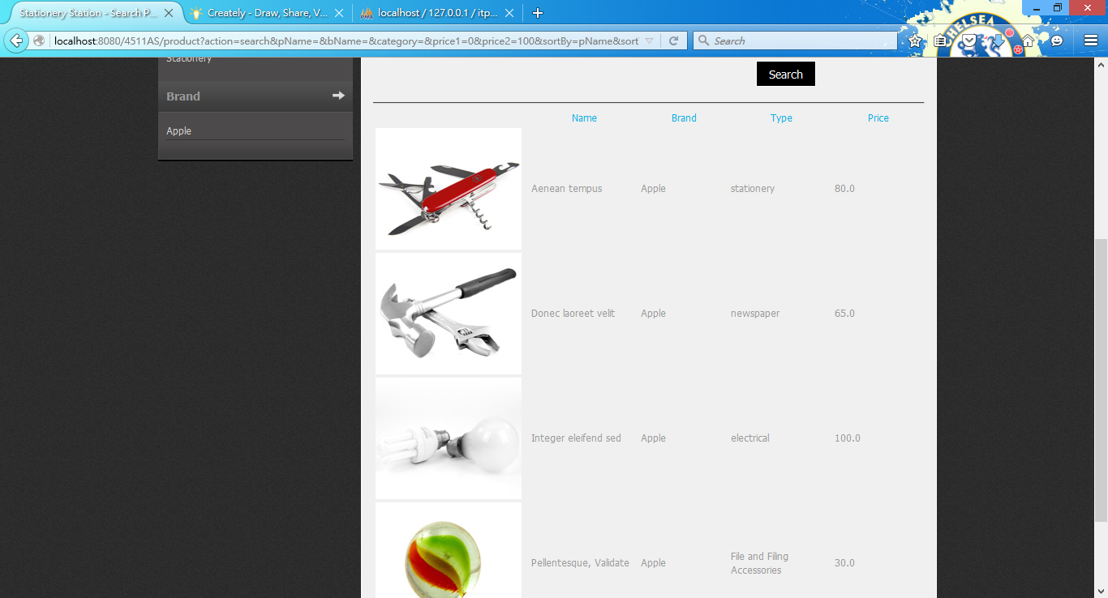

1. Add “Nam cursus facilisis”, “Mauris consectetur”, “Nulla luctus urna” to shopping cart.

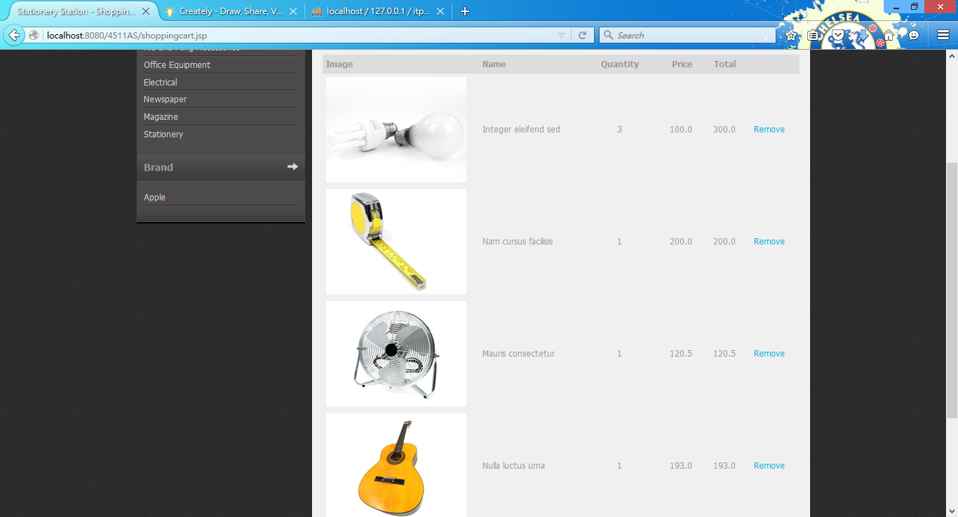

1. Remove the “Mauris consectetur”. 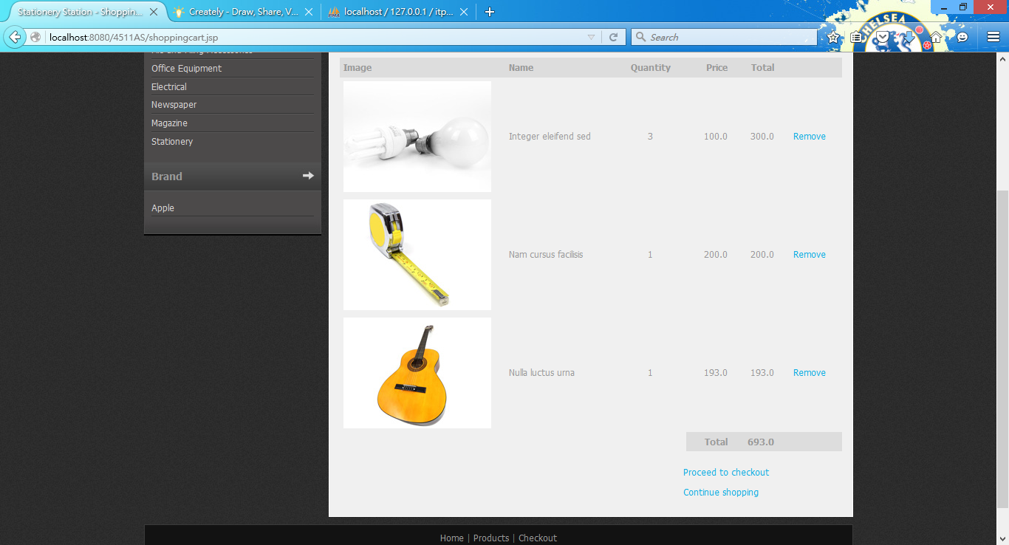
2. Click Proceed to checkout. 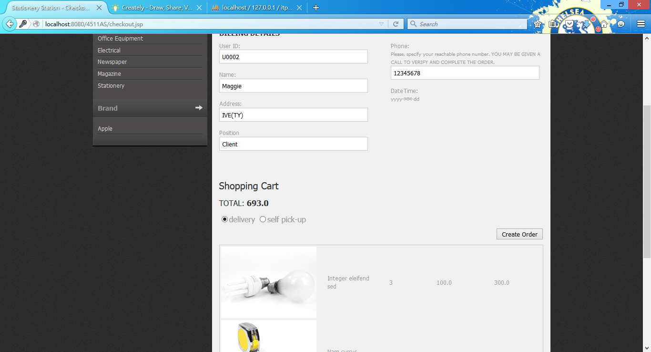
3. Click self pick-up and input a date. 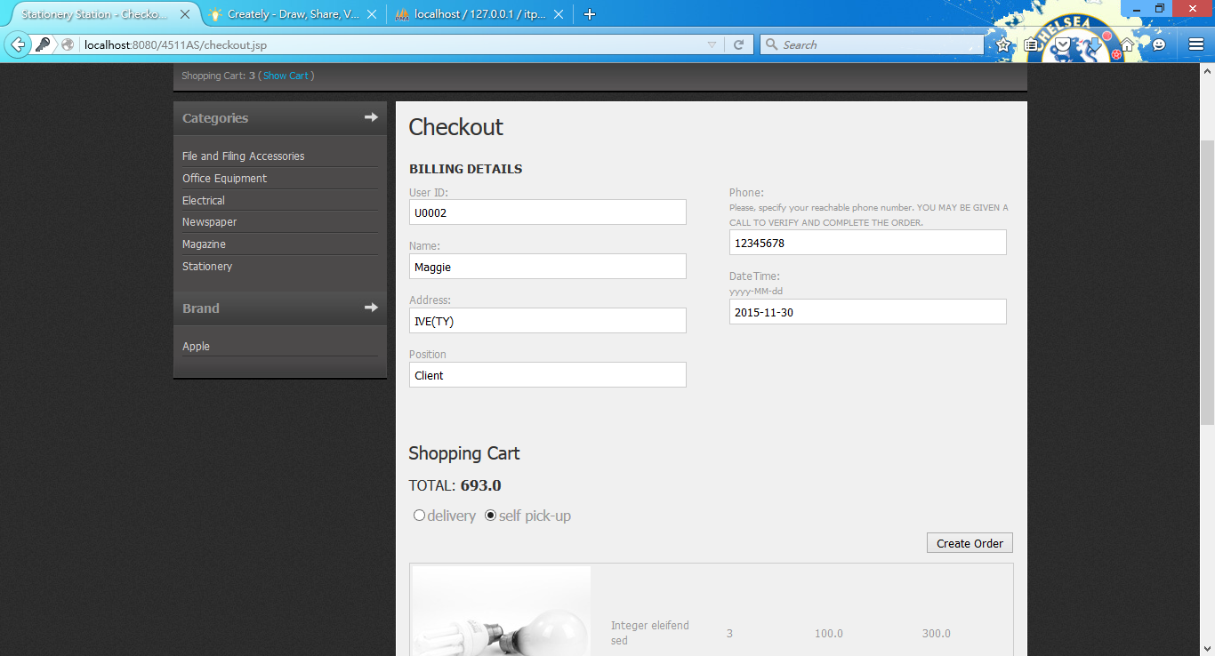
4. Click create order and show the order is created. 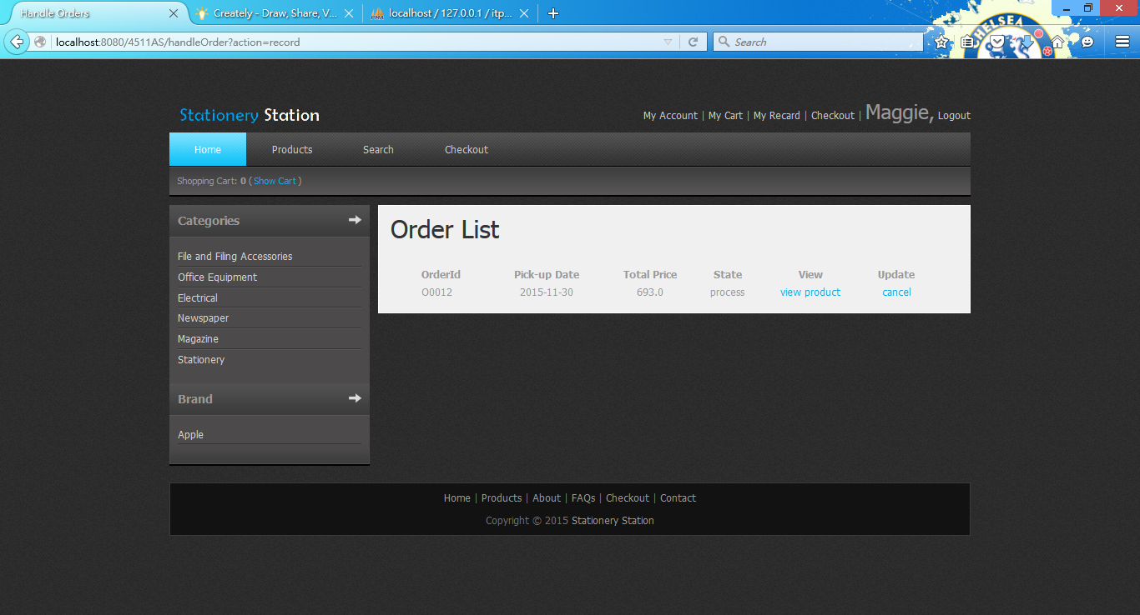
5. Click view product. 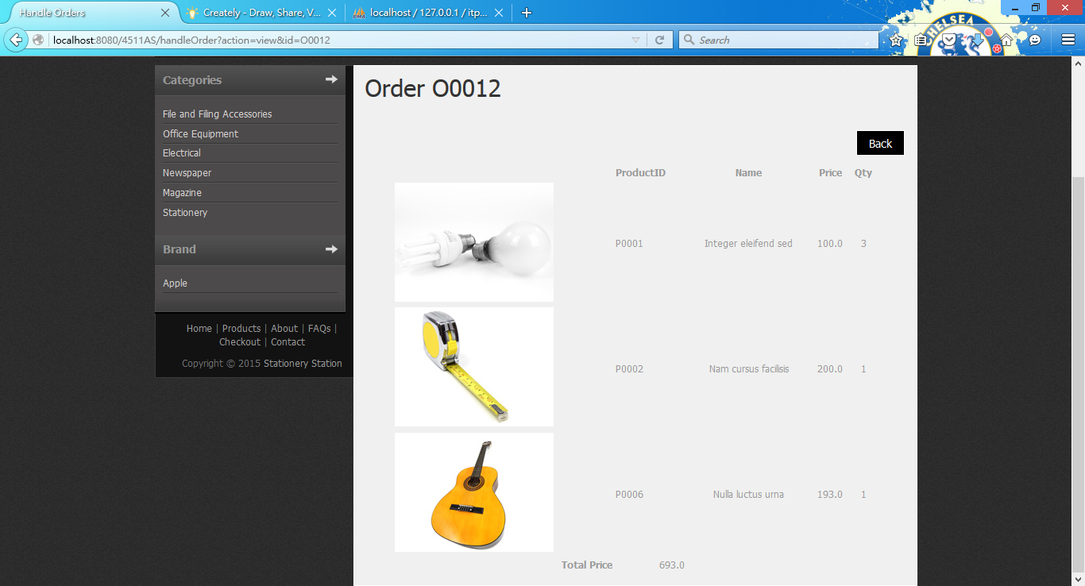
6. Create an order with total price equal to 1625.5(greater than 1000). 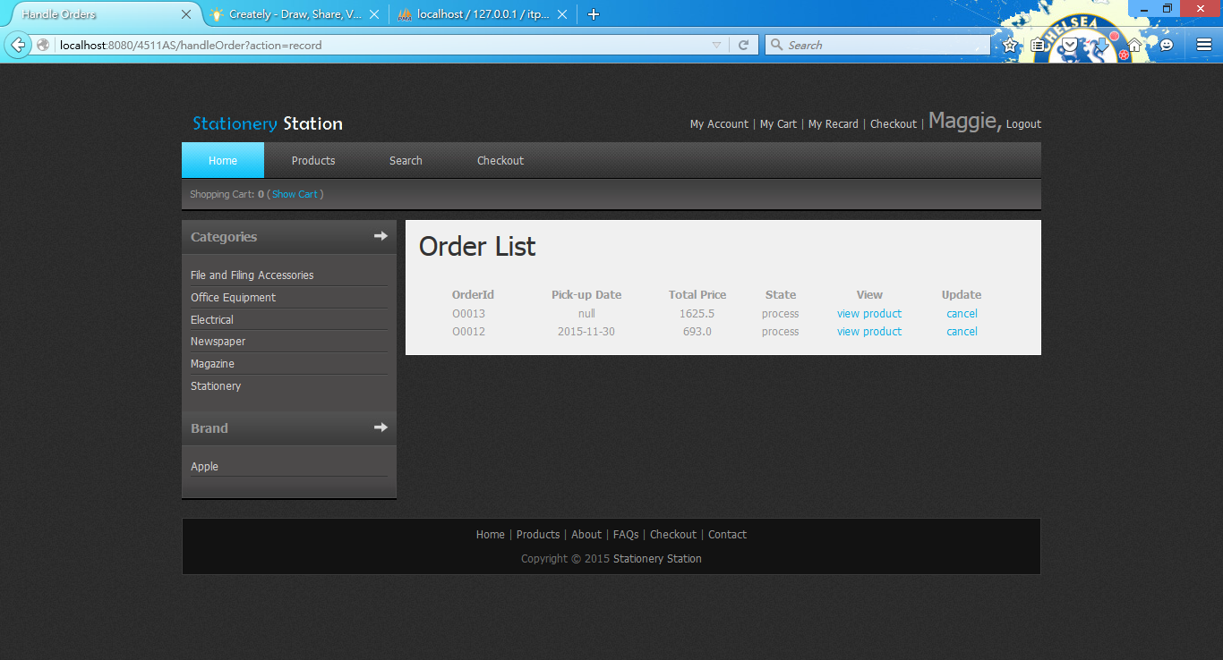
7. Click My Account and. 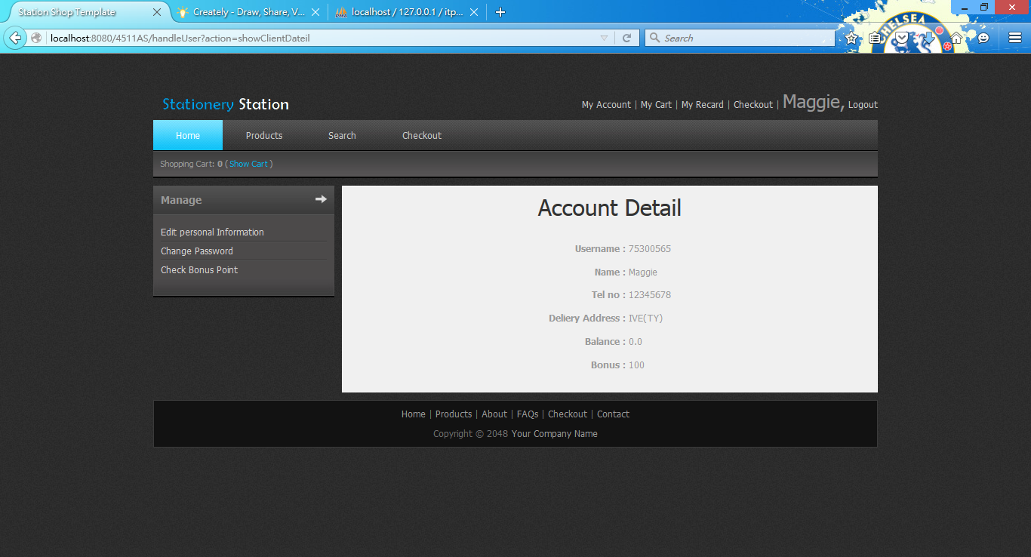
8. Click Check bonus Point and show bonus history. 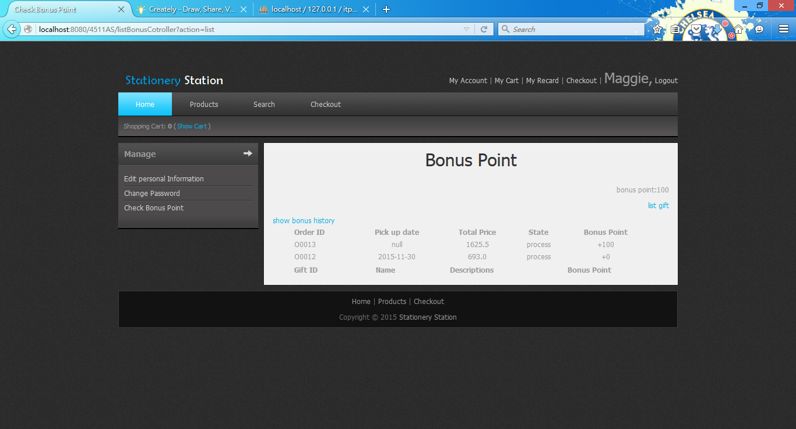
9. Click list gift to redeem gift. 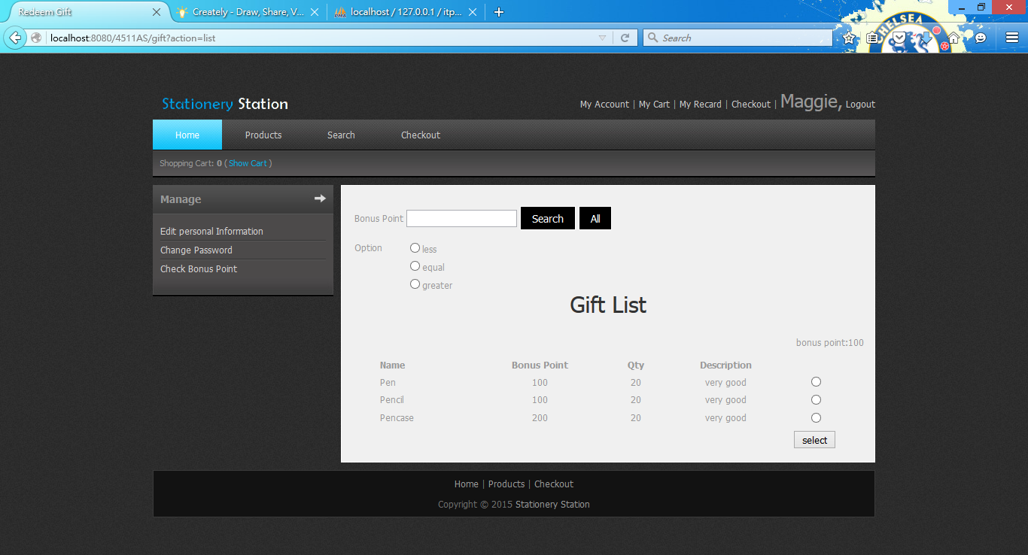
10. Search by bonus point less than 150. 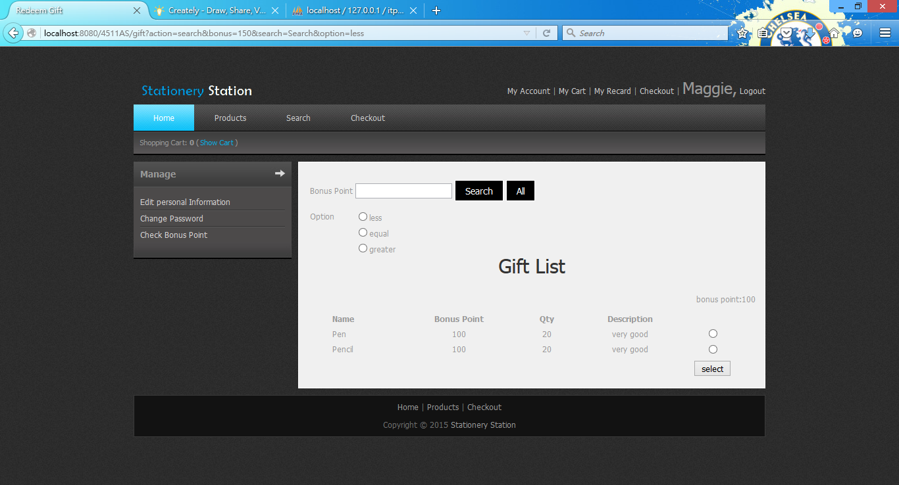
11. Click Pen and click select. 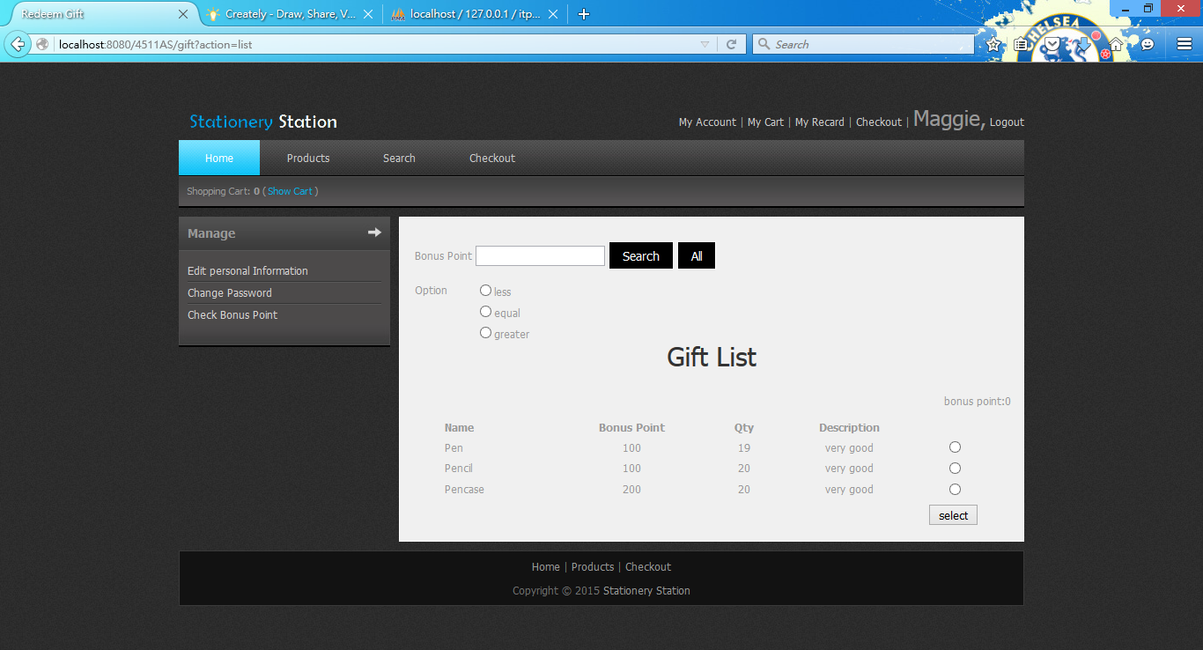
12. Repeat step 22. 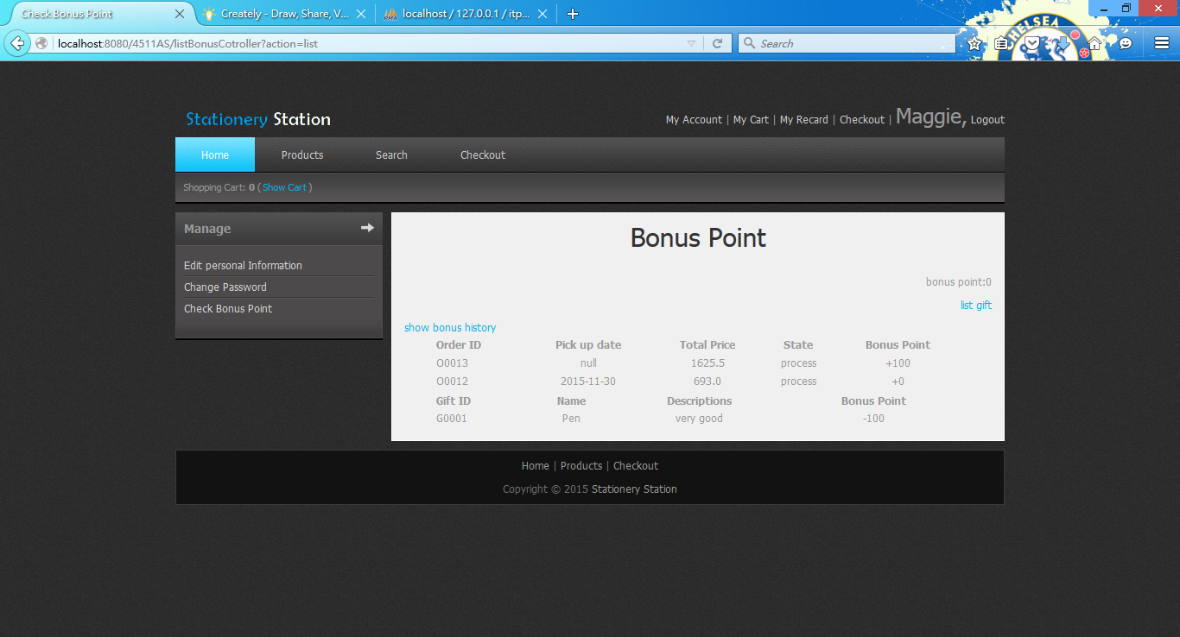
13. Click My Record and cancel the order ID O0012. 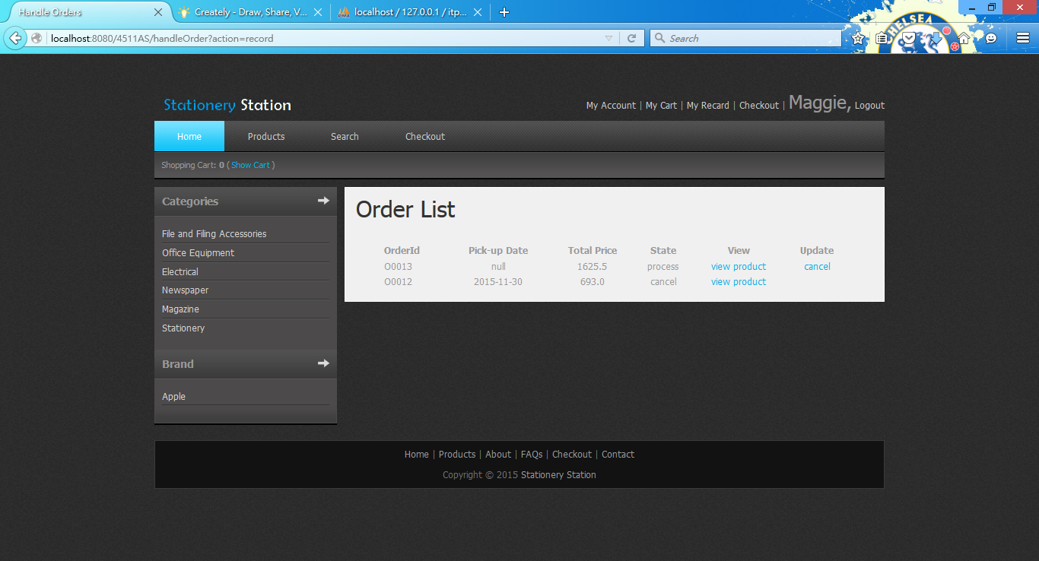
14. Log in with manager account again and click Handle Order. 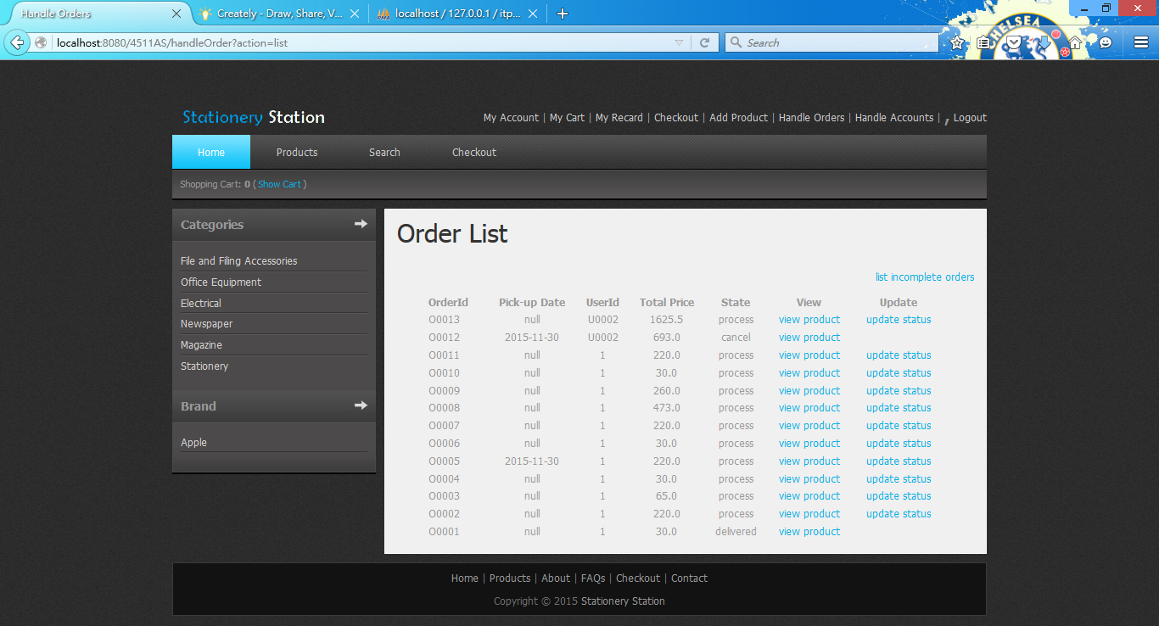
15. Click update status of order ID O0013 and change to delivered. 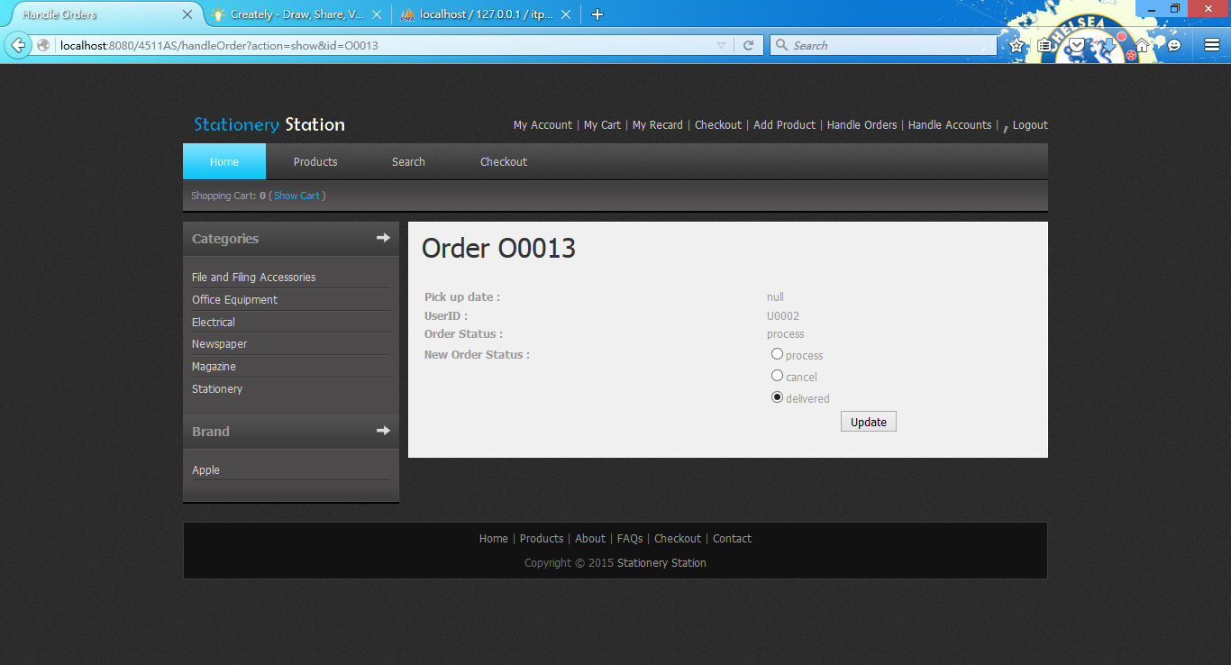
16. Click update. 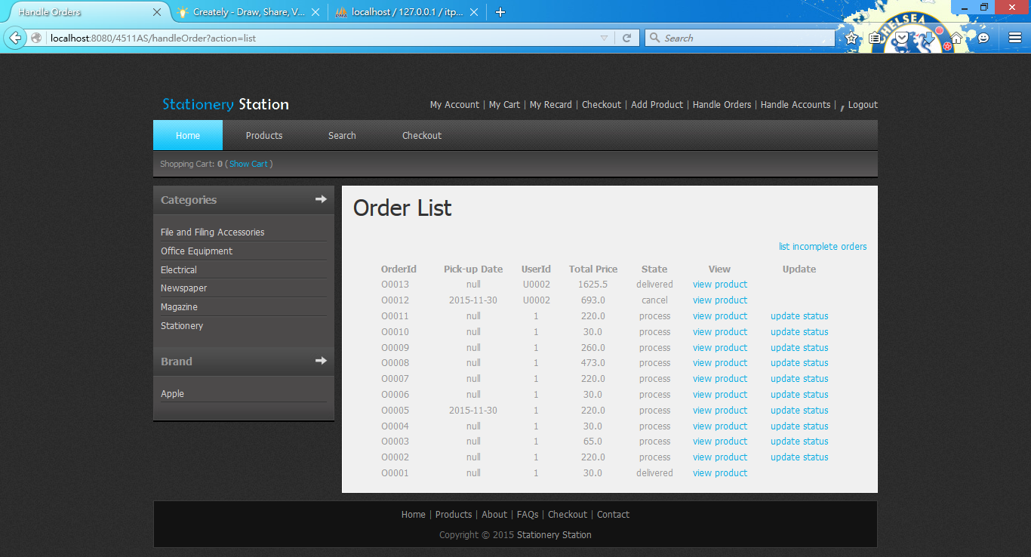
17. Click list incomplete orders. 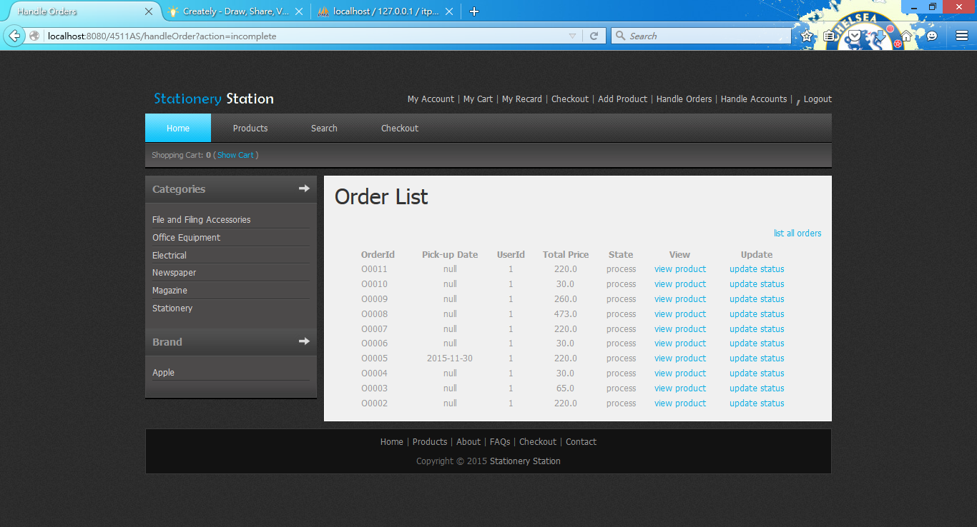
18. Click Add Product and enter a new product.

Product Name: Pencil, Price: 20, QTY: 10, Brank Name: Apple,

Product Description: very good, Category Office Equipment

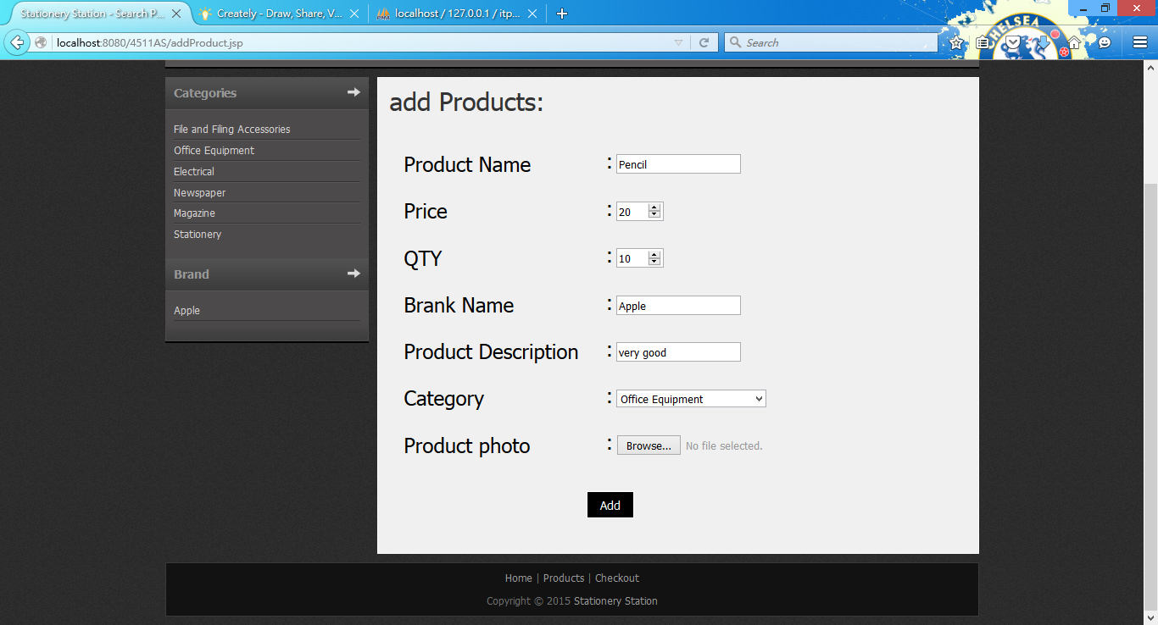

1. Click Add. 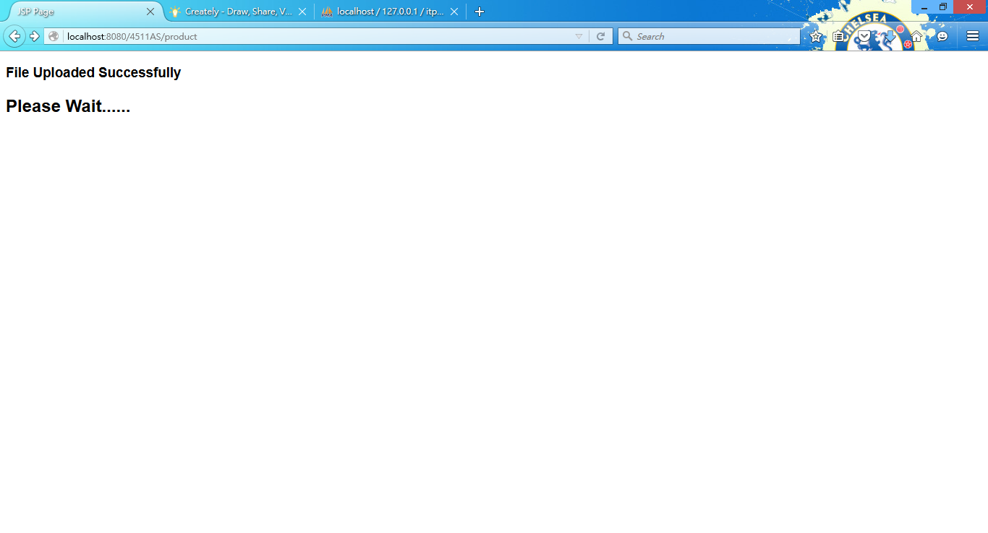 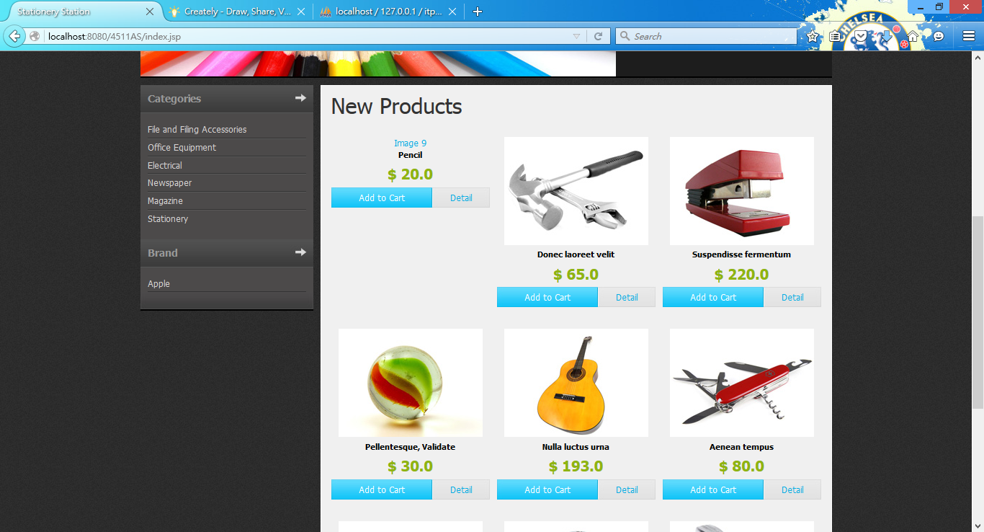
2. Click the new product detail. 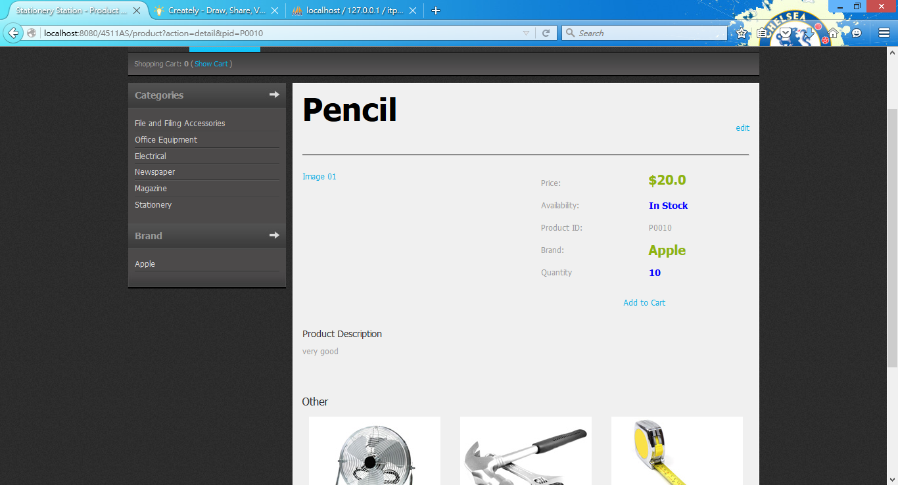
3. Click edit and change the OTY to 0. 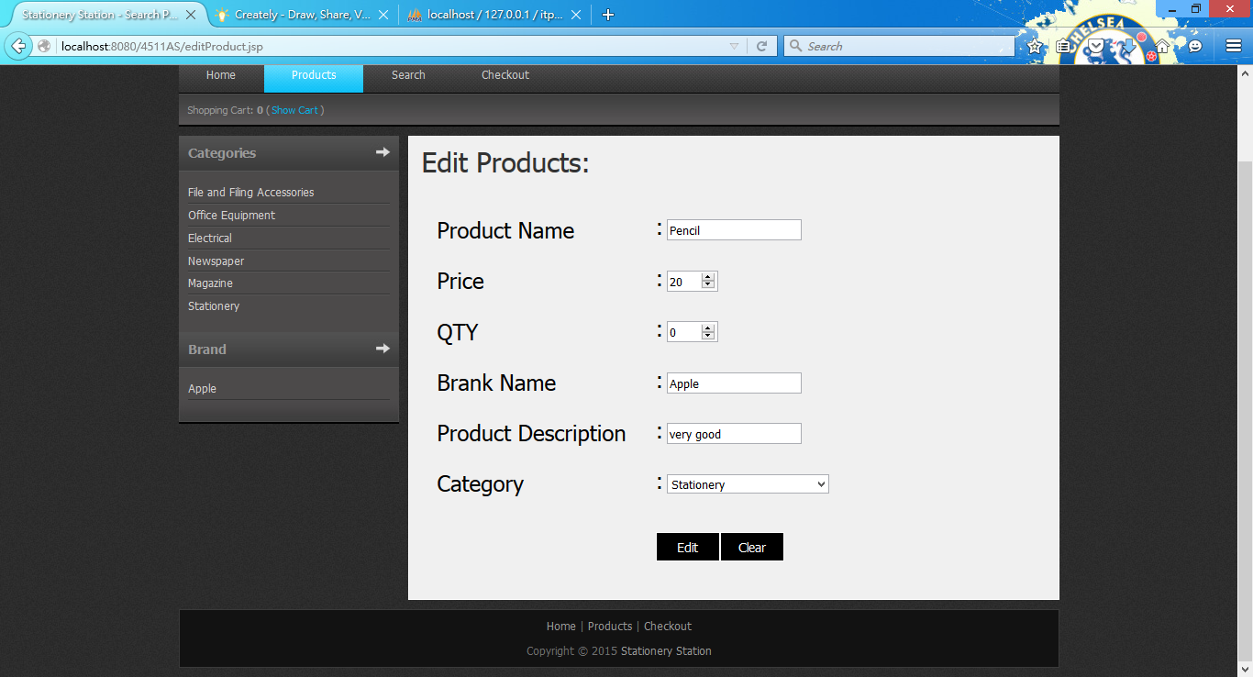
4. Click Edit. 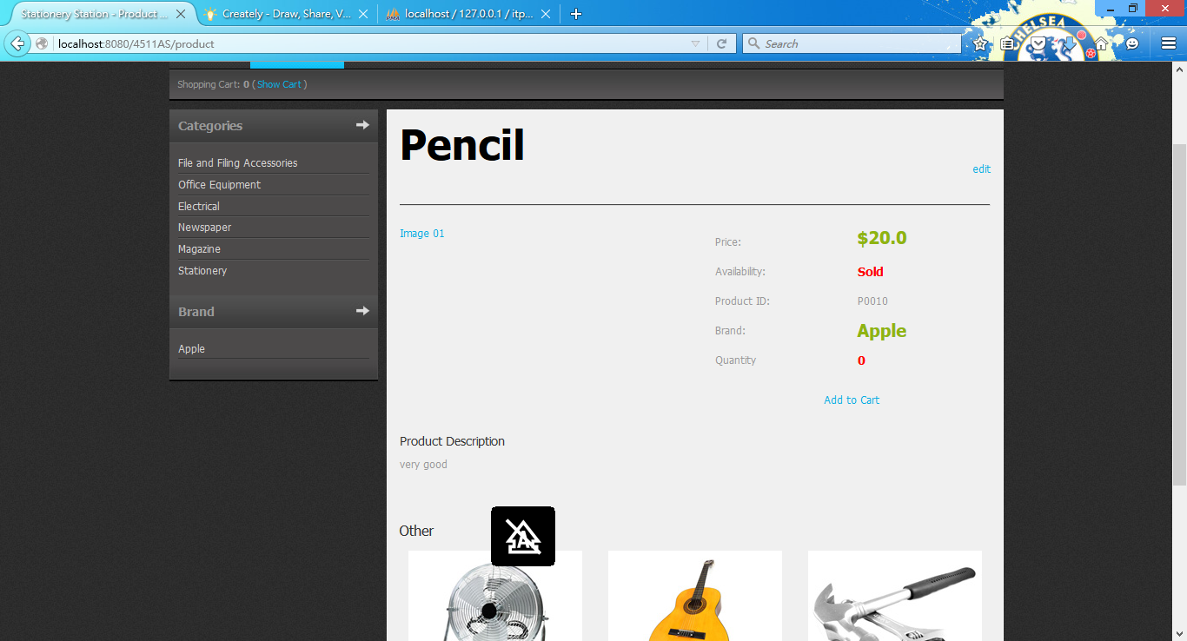
5. Add the product to cart.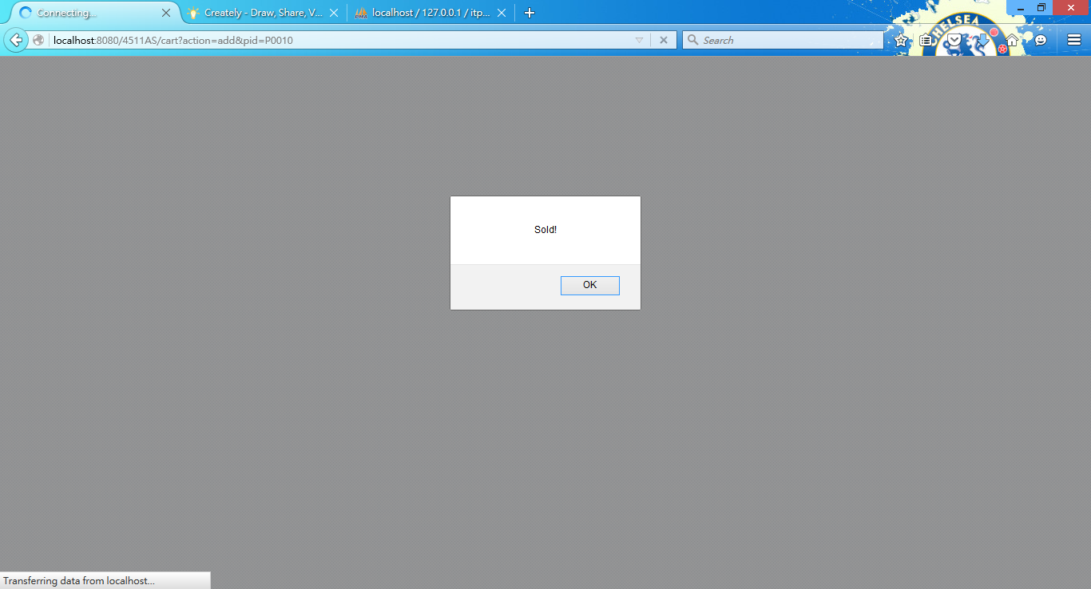
6. Brief description
7. Conclusions

In conclusion, the MVC Model is applied in the Stationery Online Station (SOS). The SOS is an easy-to-use online system for the user Client and Manager to use.

The report introduce the assumption and show the user and system requirements in the system. Also the site map, system structure and database structure are posted by photos. The details of database table is shown by table format. All the Tools, test plan and Test cases, and Brief description of the application are also mentioned. The skill checklist will be showed on the next page.

1. Skill checklist
2. Use JSP/servlets to dynamically generate HTML pages
3. Use JSP/servlets to accept user inputs from browser
4. Use JSP Action
5. Use Java bean
6. Use JDBC for database connection (MySQL)
7. Use session checking
8. Use login control
9. Apply MVC model